**Main Activity**

The MainActivity is the launcher activity in the application, so when the user opens the app the code in MainActivity class is executed.

When the app is launched MainActivity checks a SharedPrefernce to find if this is the first time the application runs on this phone. If this was found to be true this means the Sign in activity will be launched and after the completion of the registration process the welcome screens will be displayed. If not, the app will continue with MainActivity displaying the Navigation Drawer and the default fragment patient information.

The Main activity handles all the important touch events and click listeners, if the emergency button is pressed no matter what fragment is displayed at the moment it handles the event calling the emergency number, if the navigation drawer icon is clicked the drawer opens and if the user clicks a part of the screen the drawer doesn’t cover it closes and if any item is selected from the drawer main activity calls the correct fragment. MainActivity has a connection with almost all the classed in the project so simple UML diagram for MainActivity class is shown in figure x.

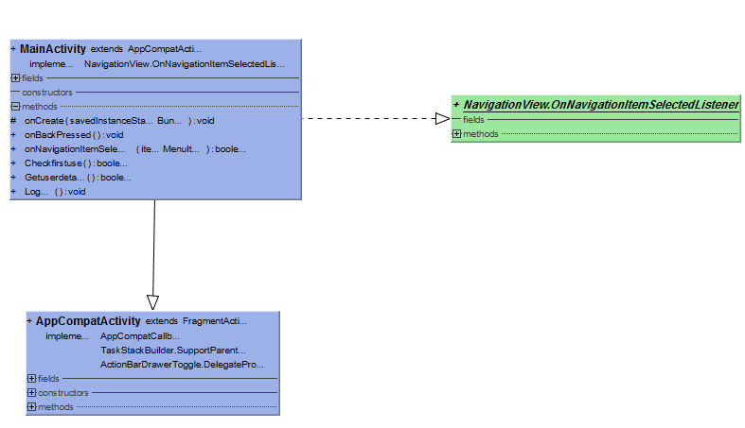

The Navigation Drawer menu

The navigation drawer menu consists of two parts the header and the body of the menu. MainActivity combine the two parts together and inflate them as one menu.

The header display some of the user information and if a photo of him exists it will be added to the header. Figure x shows the header of the menu

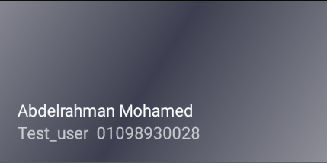

Figure x: The Navigation Drawer menu header.

The second part is the menu body which contains the items that the user chooses from to navigate through the application different tabs and use it’s features. The items are divided into three different groups the main group that contains main features, the communication group that contains features related to communicating with the doctor and others group contain options like the settings. Figures x, x and x shows the three groups.

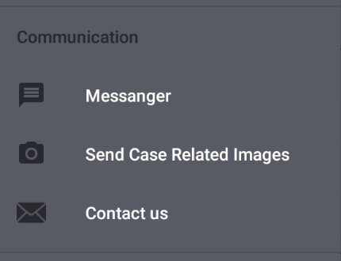 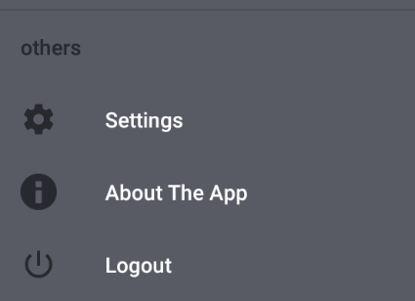

Figure x: Communications group Figure x: Others group

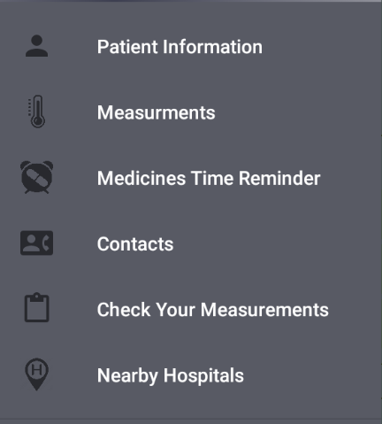  
Figure x: Main features group

The emergency button is important to the application as it allow the patient to make a phone call with one simple click, the button exists in all the application tabs and as mentioned above MainActivity handles its click listener. A floating button is used so it can be in any screen in the application and its placed at the bottom right of the screen, Figure x show how the button looks.



Figure x: Emergency Floating button

The drawer opens by clicking the icon at the top left of the screen next to the app name, Figures x and x+1 show this operation, the menu with all it’s parts and the floating emergency button.

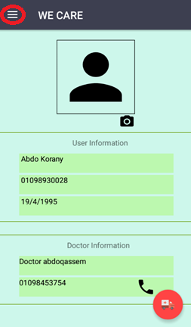 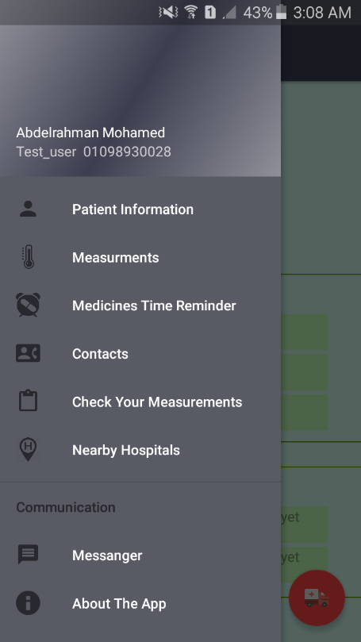 Figure x: The Drawer button Figure x: The opened drawer menu

In the next section the fragments launched by selecting items from the menu will be discussed one by one.